Salesforce Administrator Self-Learning & Super Badges

[**LIGHTNING EXPERIENCE REPORTS & DASHBOARDS SPECIALIST - SUPERBADGE**](https://smartinternz.com/Student/guided_project_workspace/47025#collapse3)

# Reports & Dashboards for Lightning Experience

# **Introduction to Reports and Dashboards in Lightning Experience**

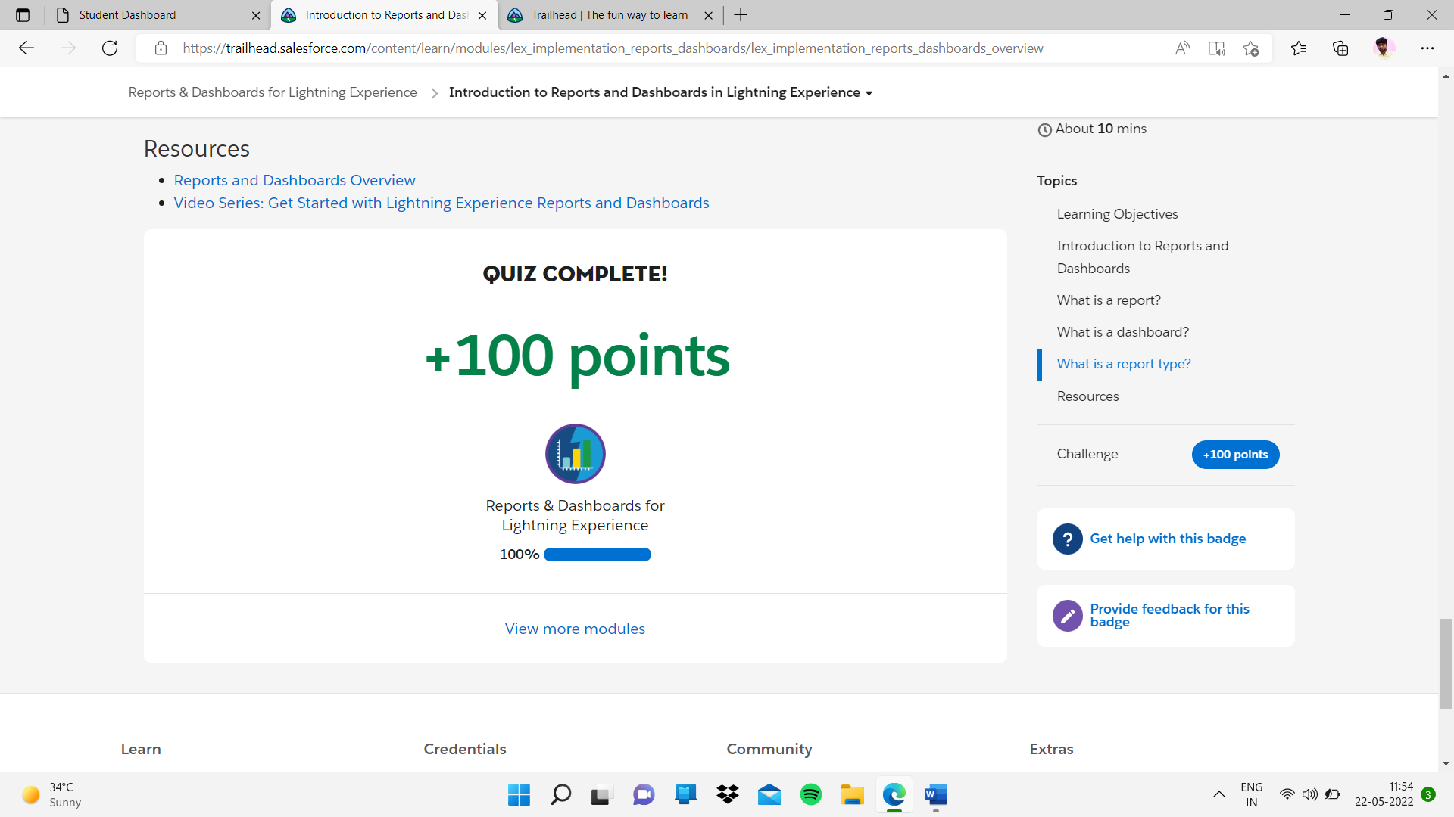

# **Create Reports with the Report Builder**

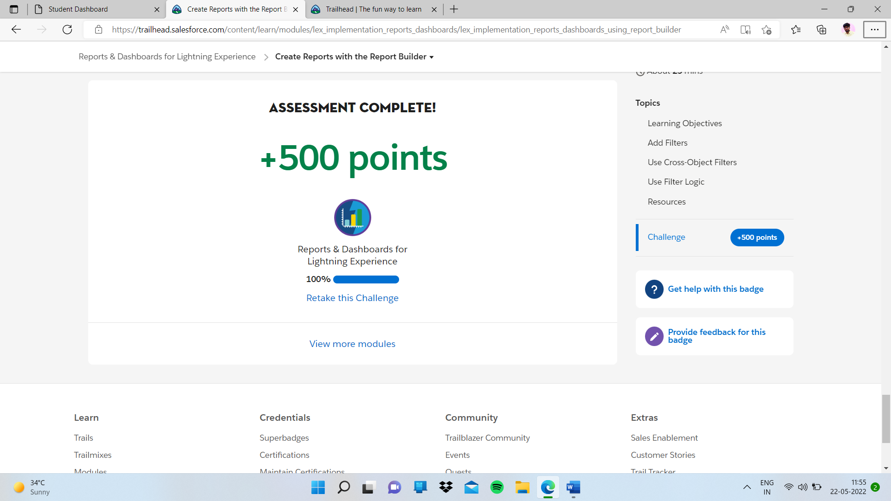

# **Format Reports**

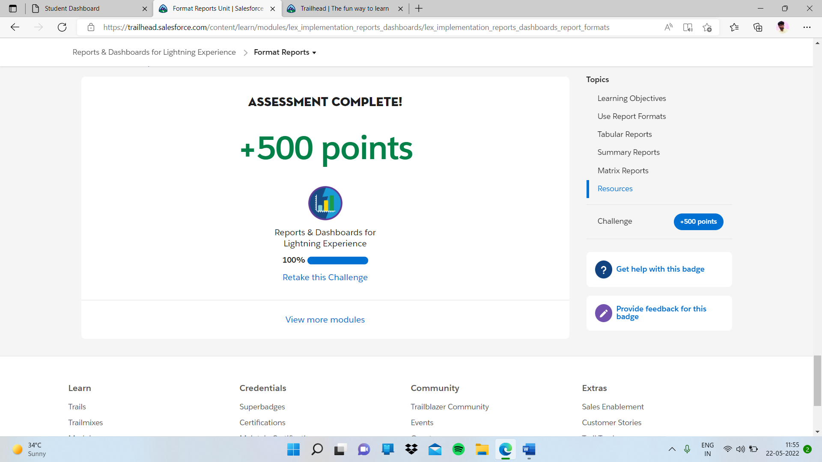

# **Visualize Your Data with the Lightning Dashboard Builder**

# **Extend Your Reporting Strategy with AppExchange**

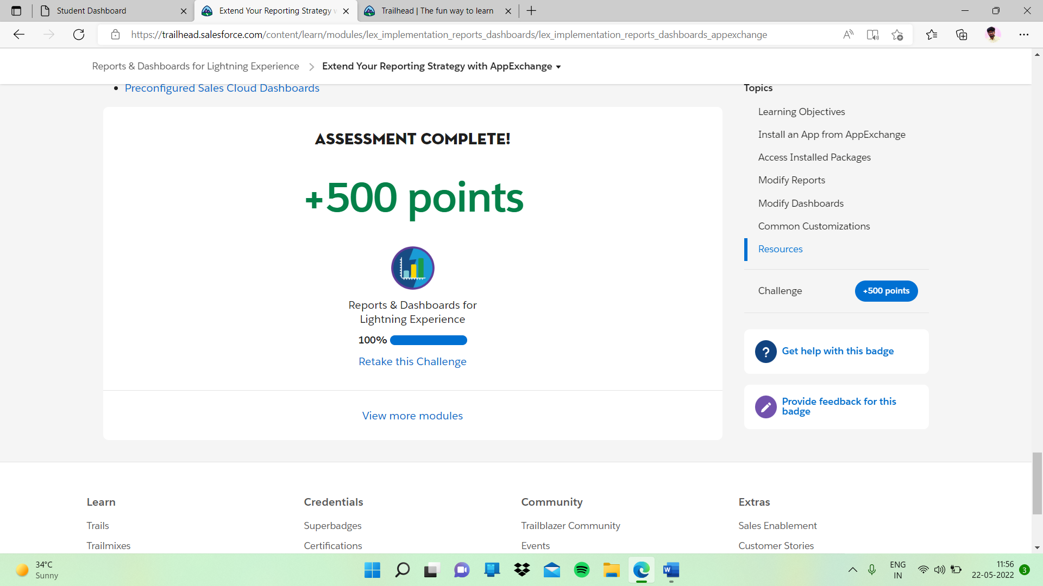

# Create Reports and Dashboards for Sales and Marketing Managers

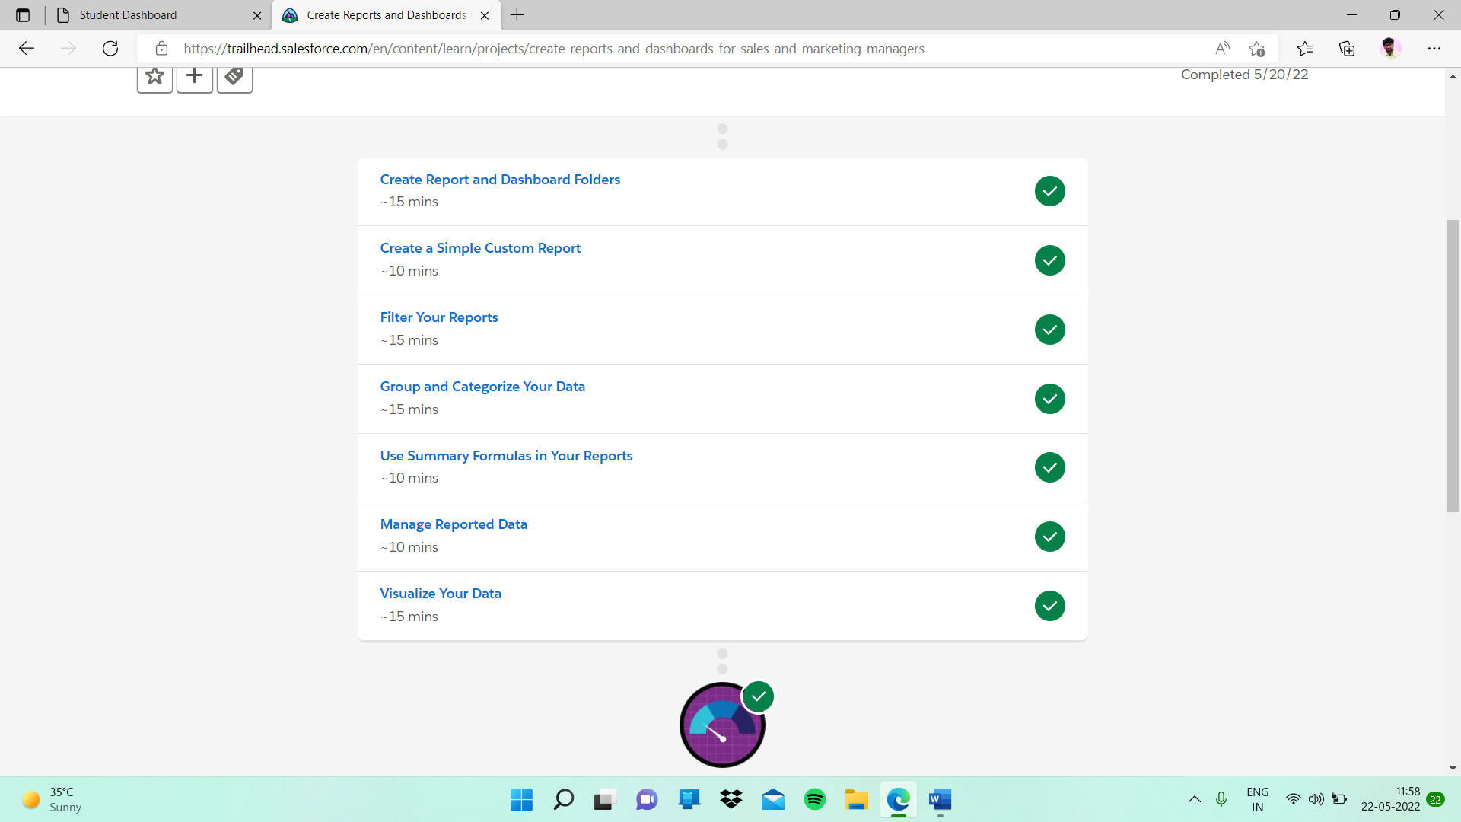

# **Create Report and Dashboard Folders**

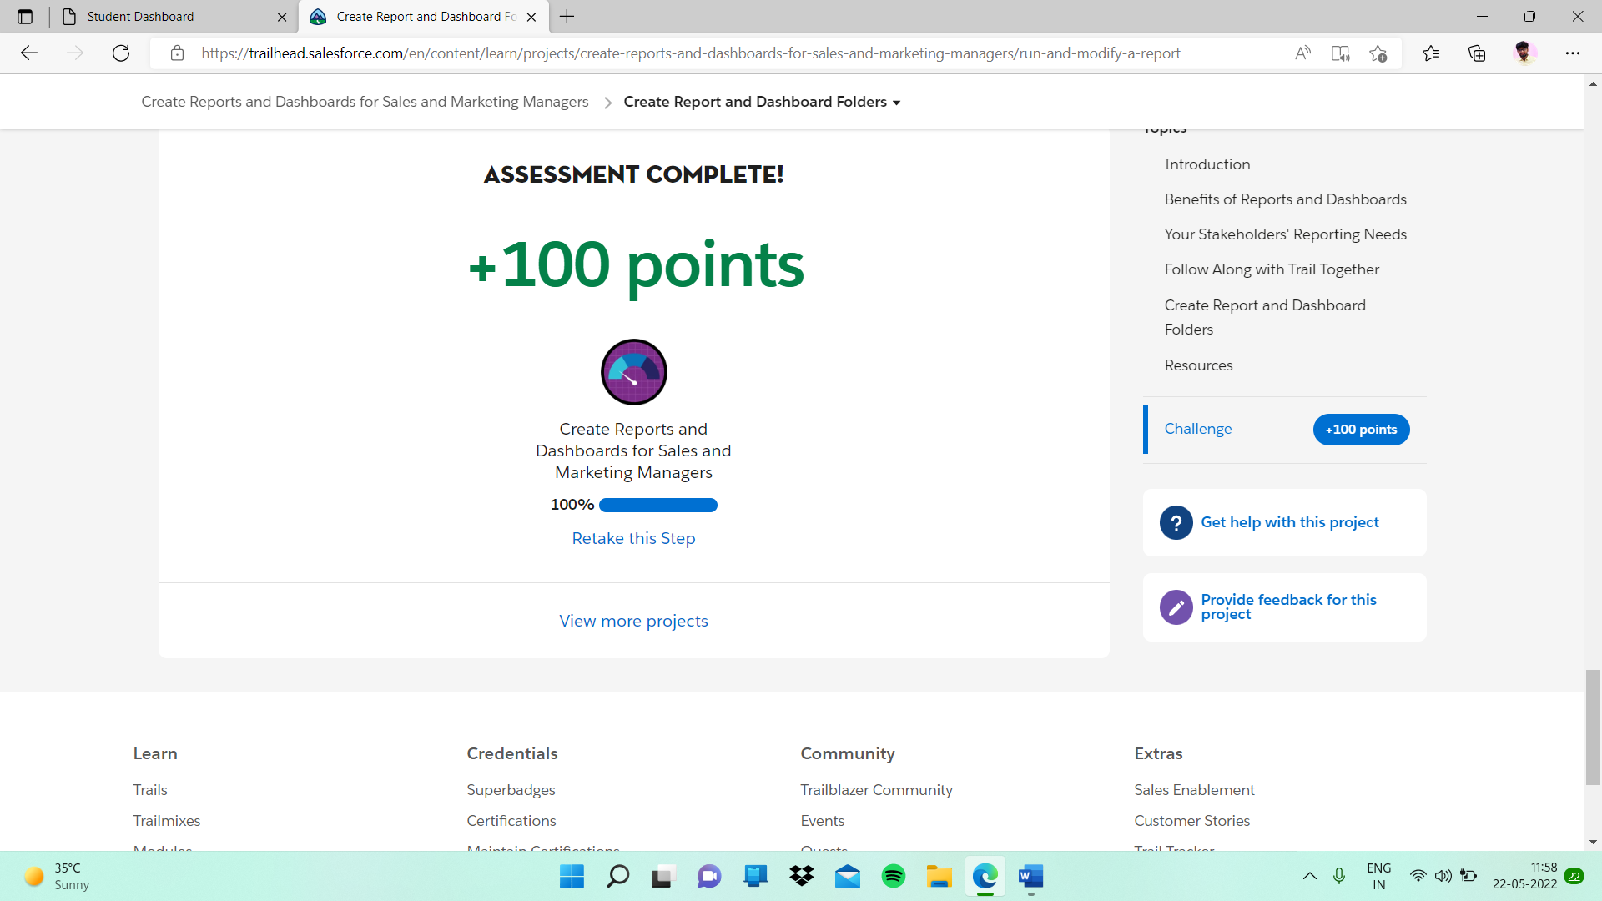

# **Create a Simple Custom Report**

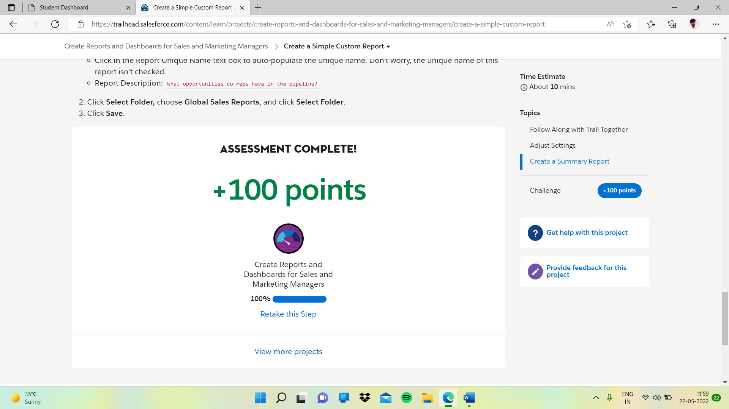

# **Filter Your Reports**

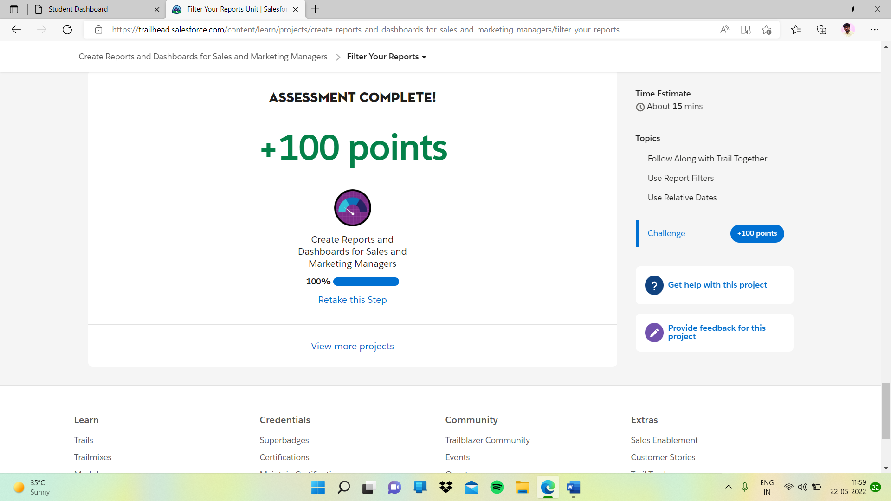

# **Group and Categorize Your Data**

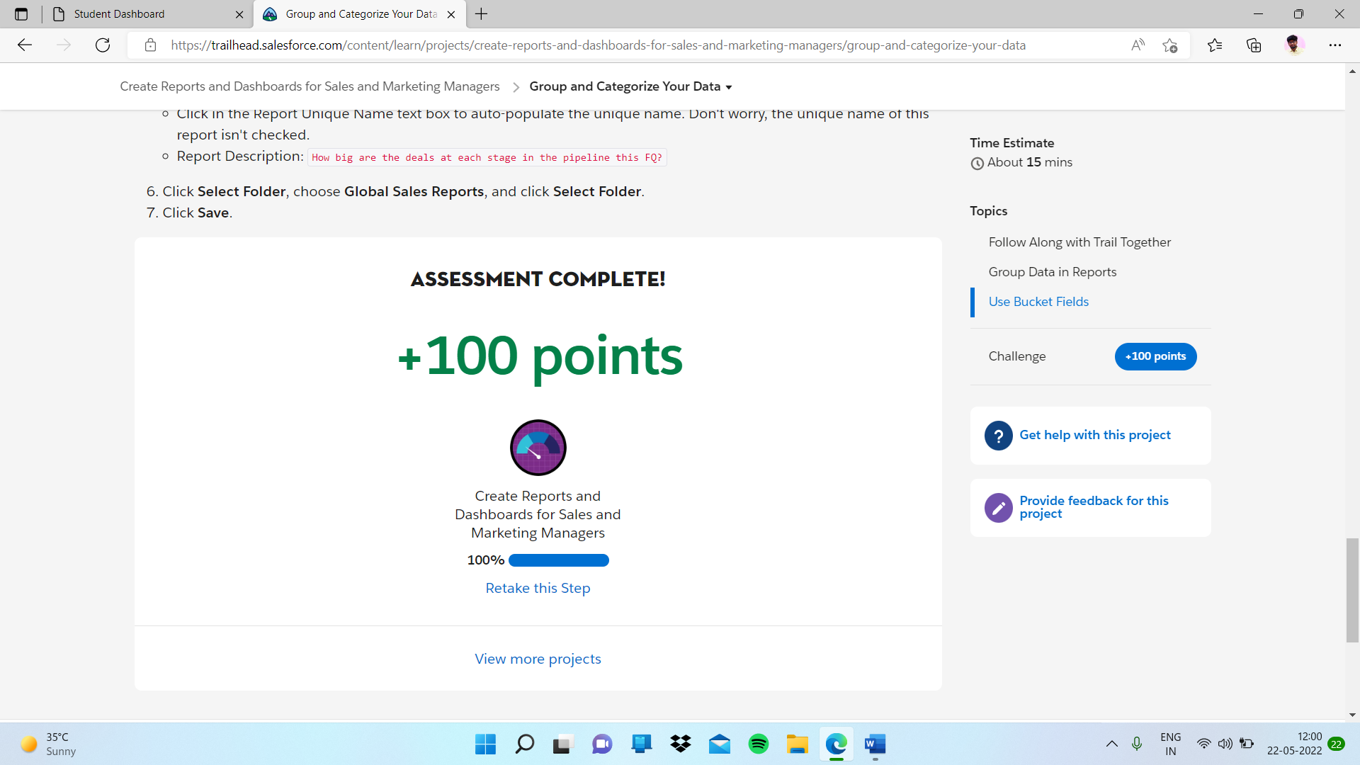

# **Use Summary Formulas in Your Reports**

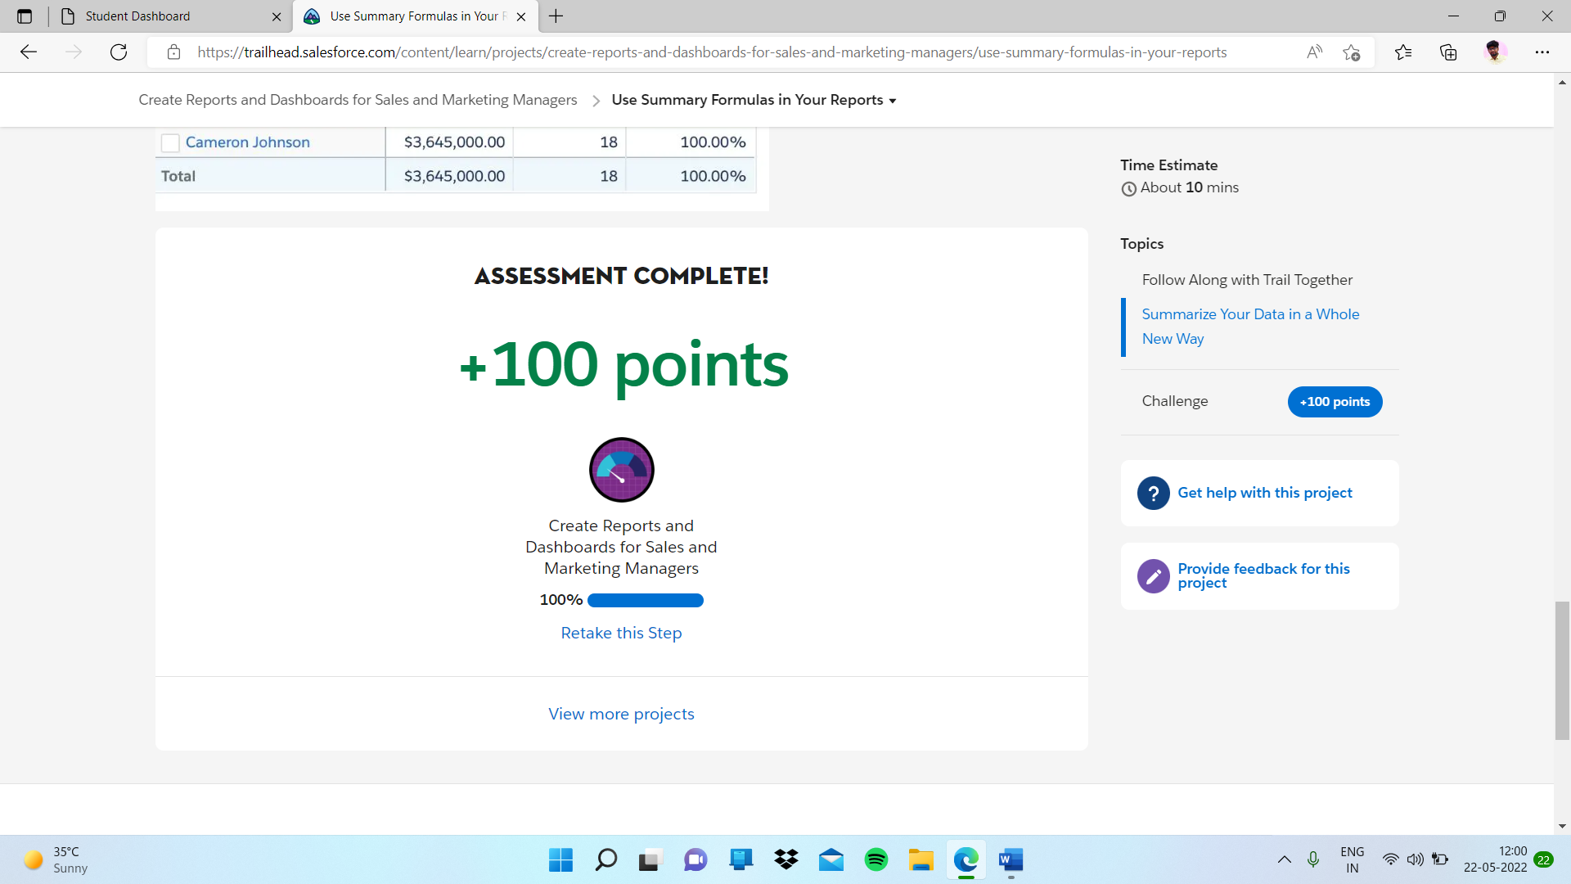

# **Manage Reported Data**

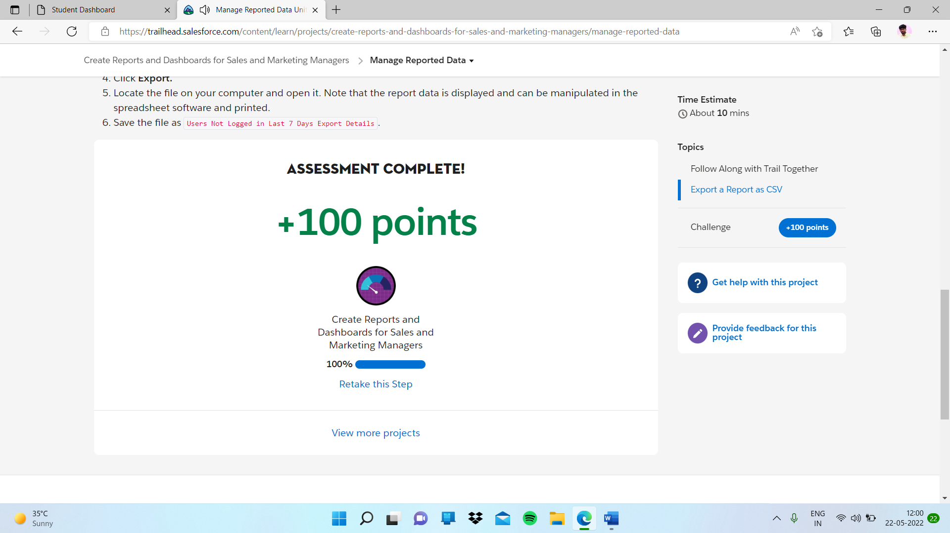

# **Visualize Your Data**

# 